EE 210

HW#: 04

Last Name: **Aldacher**

First Name: **Muhammad**

ID: **011510317**

Date: **9/25/2020**

Assigned question #s: **7**

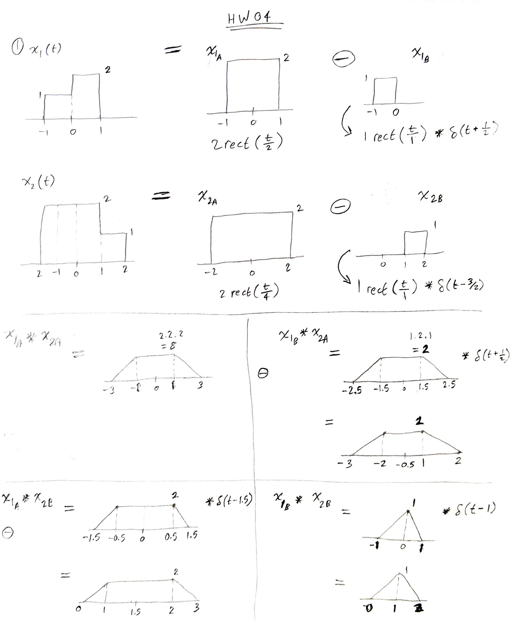

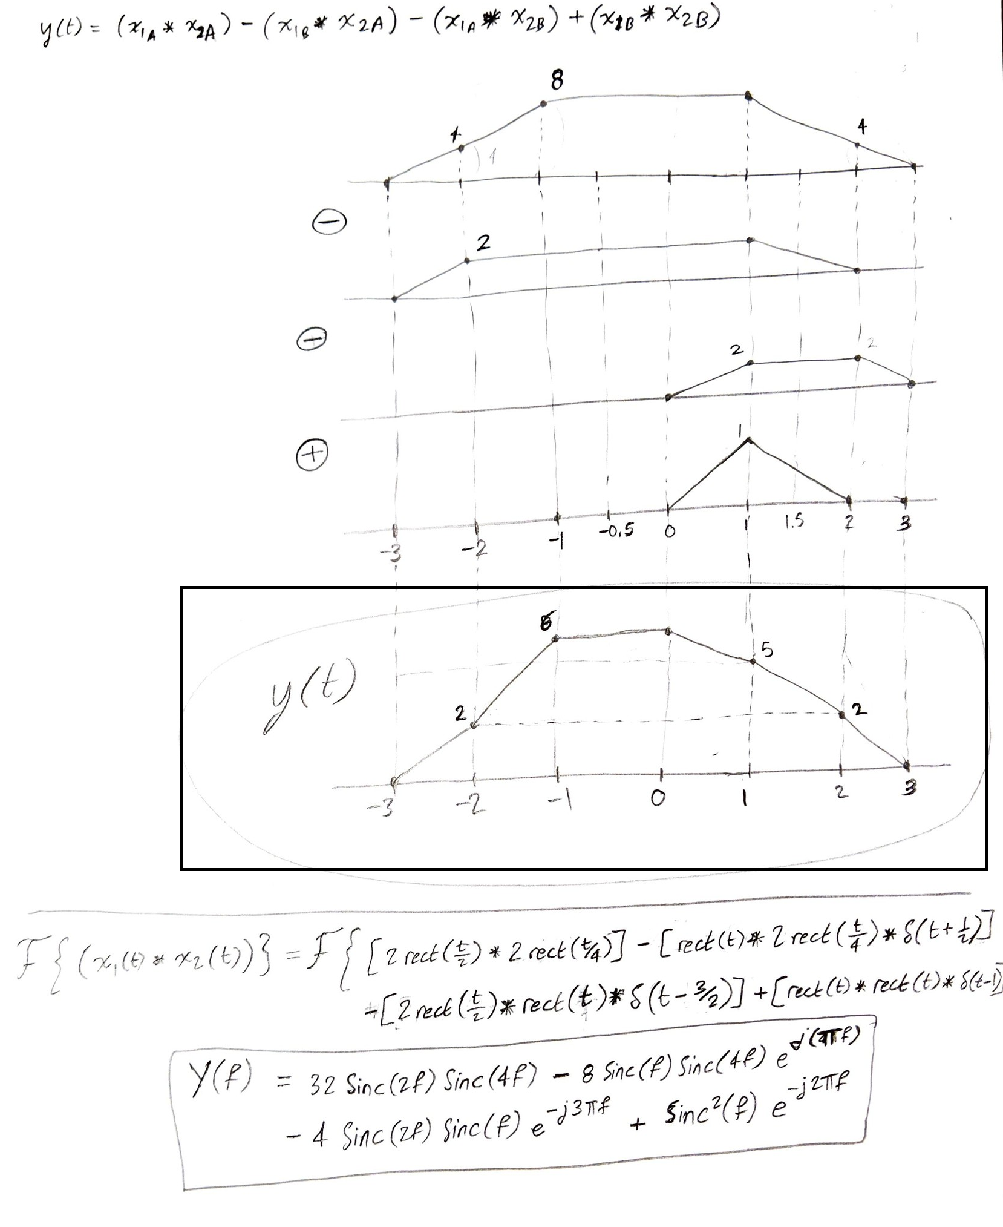

Matlab Code for Q1

1. Time Domain:

tstep=0.01; tstart=-3; tend=3;

t=tstart:tstep:tend;

%x1(t) Function

for m=1:1:length(t)

if (t(m) >= -1)&&(t(m) <= 0)

x1(m) = 1;

elseif (t(m) > 0)&&(t(m) <= 1)

x1(m) = 2;

else

x1(m) = 0;

end

end

subplot(1,3,1); plot(t,x1); axis([-2 2 -0.05 2.05]); title("x1(t)"); grid on;

%x2(t) Function

for m=1:1:length(t)

if (t(m) >= -2)&&(t(m) <= 1)

x2(m) = 2;

elseif (t(m) > 1)&&(t(m) <= 2)

x2(m) = 1;

else

x2(m) = 0;

end

end

subplot(1,3,2); plot(t,x2); axis([-3 3 -0.05 2.05]); title("x2(t)"); grid on;

y = conv(x1,x2)

y = y.*tstep

t_2x=(tstart*2):tstep:(tend*2);

subplot(1,3,3); plot(t_2x,y); axis([-4 4 -0.05 6.05]); title("y(t)"); grid on;

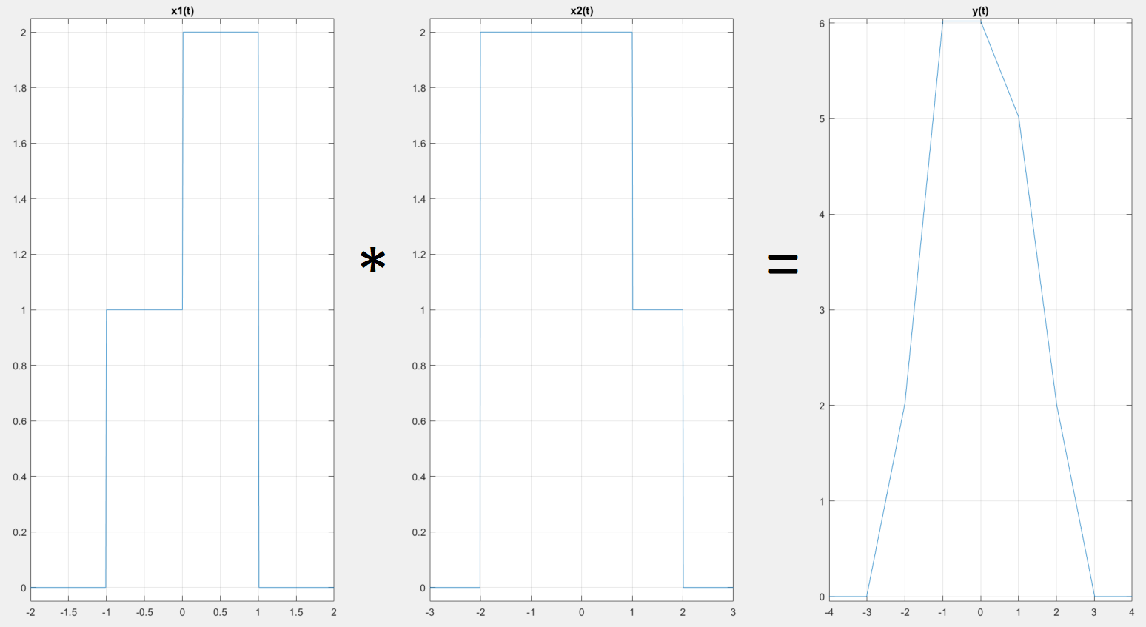

1. Frequency Domain:

syms f t

ex = exp(-j*2*pi*f*t);

x1a = 1; x1b = 2;

X1 = int(x1a*ex,t,-1,0)+int(x1b*ex,t,0,1);

x2a = 2; x2b = 1;

X2 = int(x2a*ex,t,-2,1)+int(x2b*ex,t,1,2);

Y = X1*X2;

Y = simplify(Y)

subplot(2,1,1); fplot(f,abs(Y)); axis([-6 6 -0.08 22]); title('Magnitue(Y)'); grid on;

subplot(2,1,2); fplot(angle(Y)); axis([-6 6 -3.5 3.5]); title('Phase(Y)'); grid on;

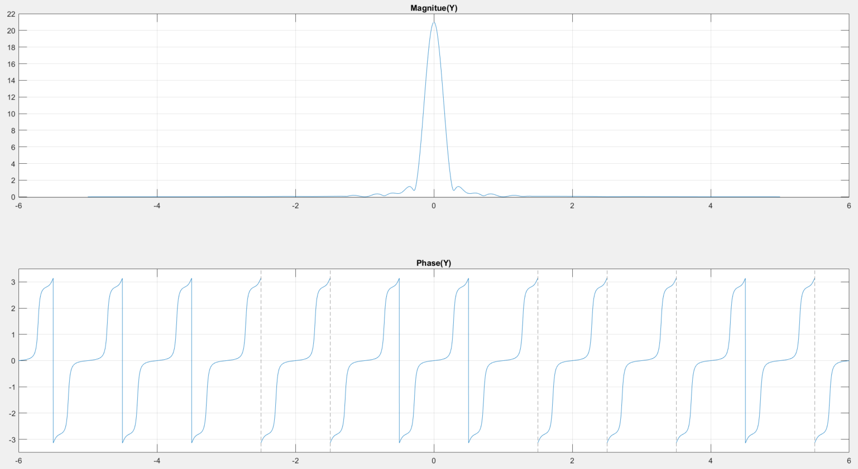

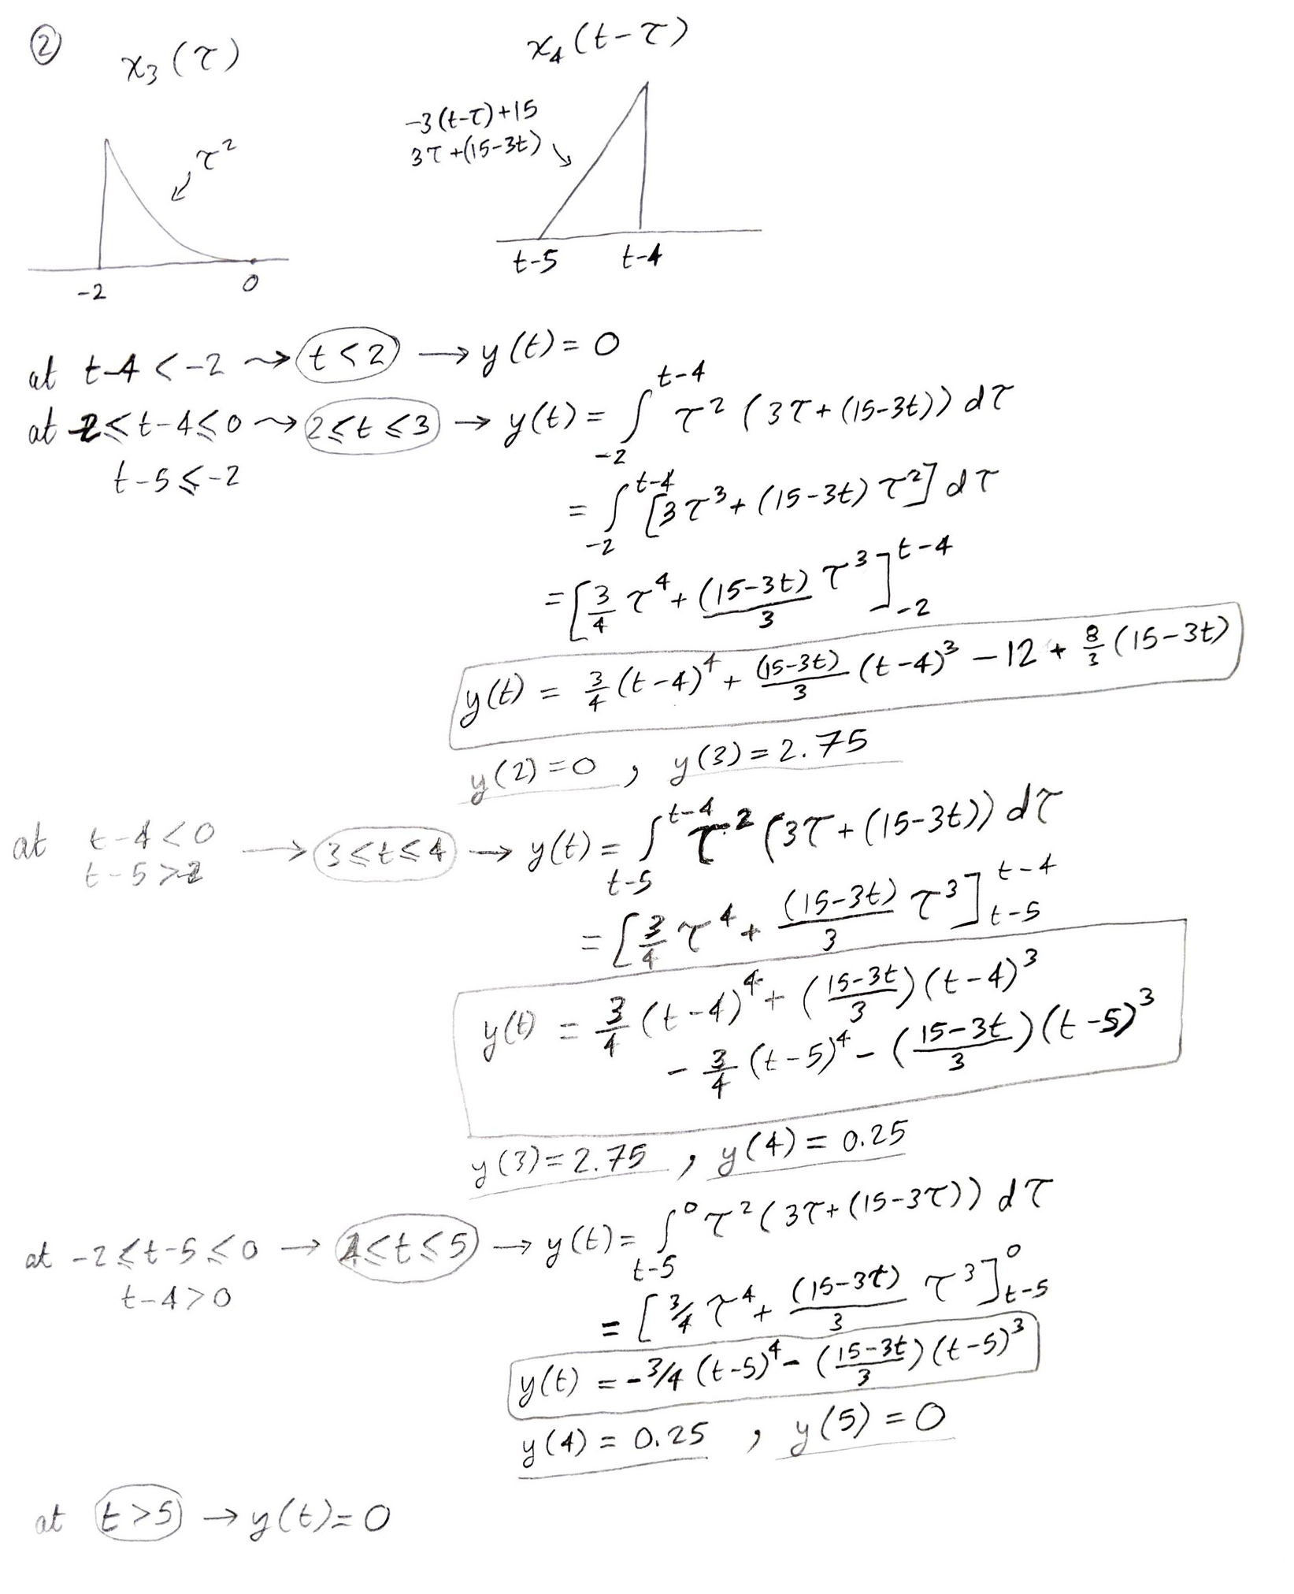

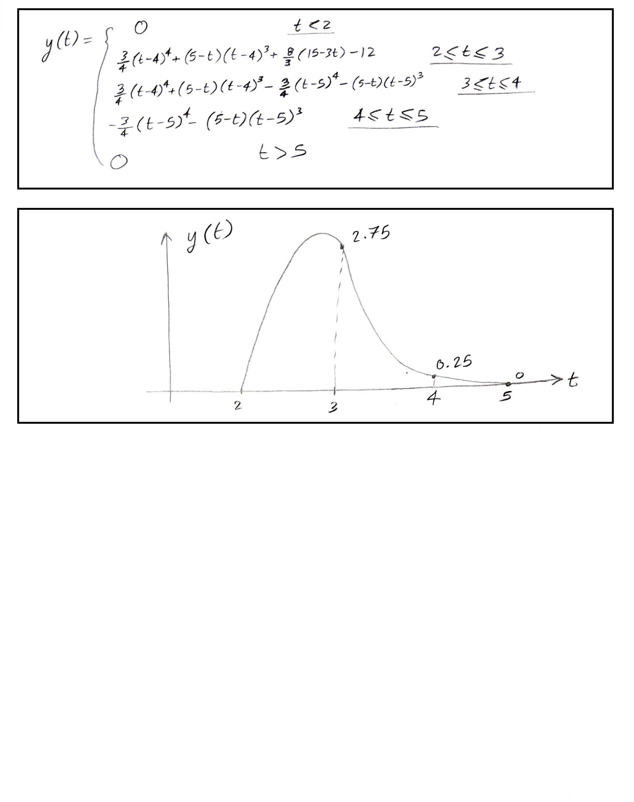

Matlab Code for Q2

clc; clear all; close all;

tstart=-6; tstep=0.01; tend=6;

t=tstart:tstep:tend;

%x1(t) Function

for m=1:1:length(t)

if (t(m) >= -2)&&(t(m) <= 0)

x1(m) = t(m)^2;

else

x1(m) = 0;

end

end

figure; plot(t,x1);

%x2(t) Function

for m=1:1:length(t)

if (t(m) >= 4)&&(t(m) <= 5)

x2(m) = (-3*t(m))+15;

else

x2(m) = 0;

end

end

figure; plot(t,x2);

y = conv(x1,x2)

y = y.*tstep

t_2x=(tstart*2):tstep:(tend*2);

figure; plot(t_2x,y)

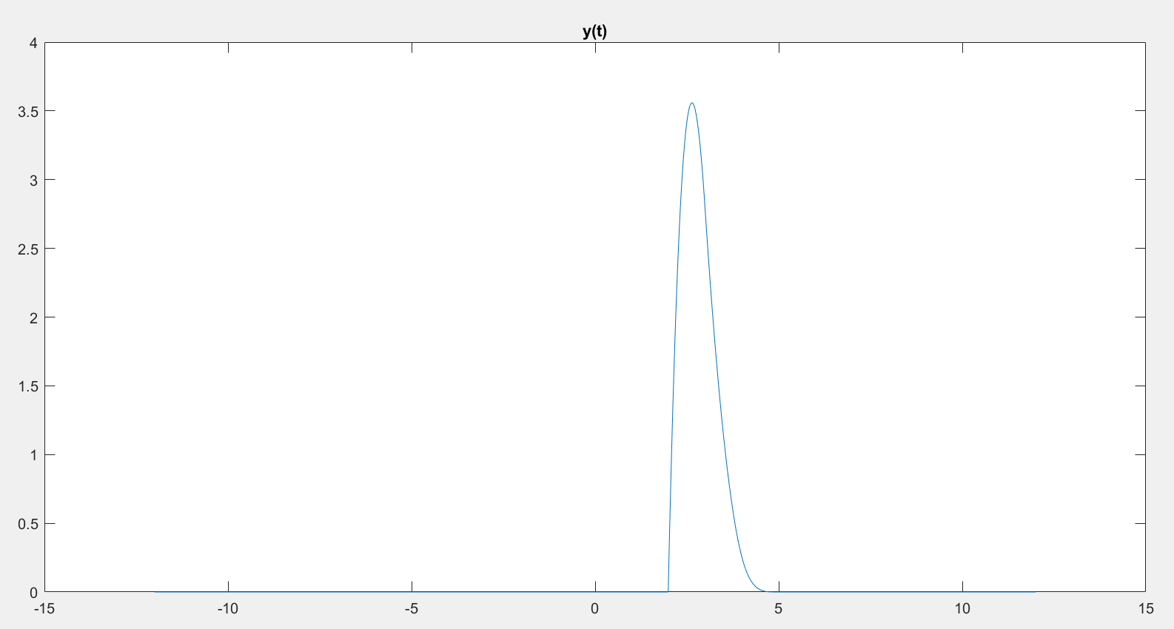

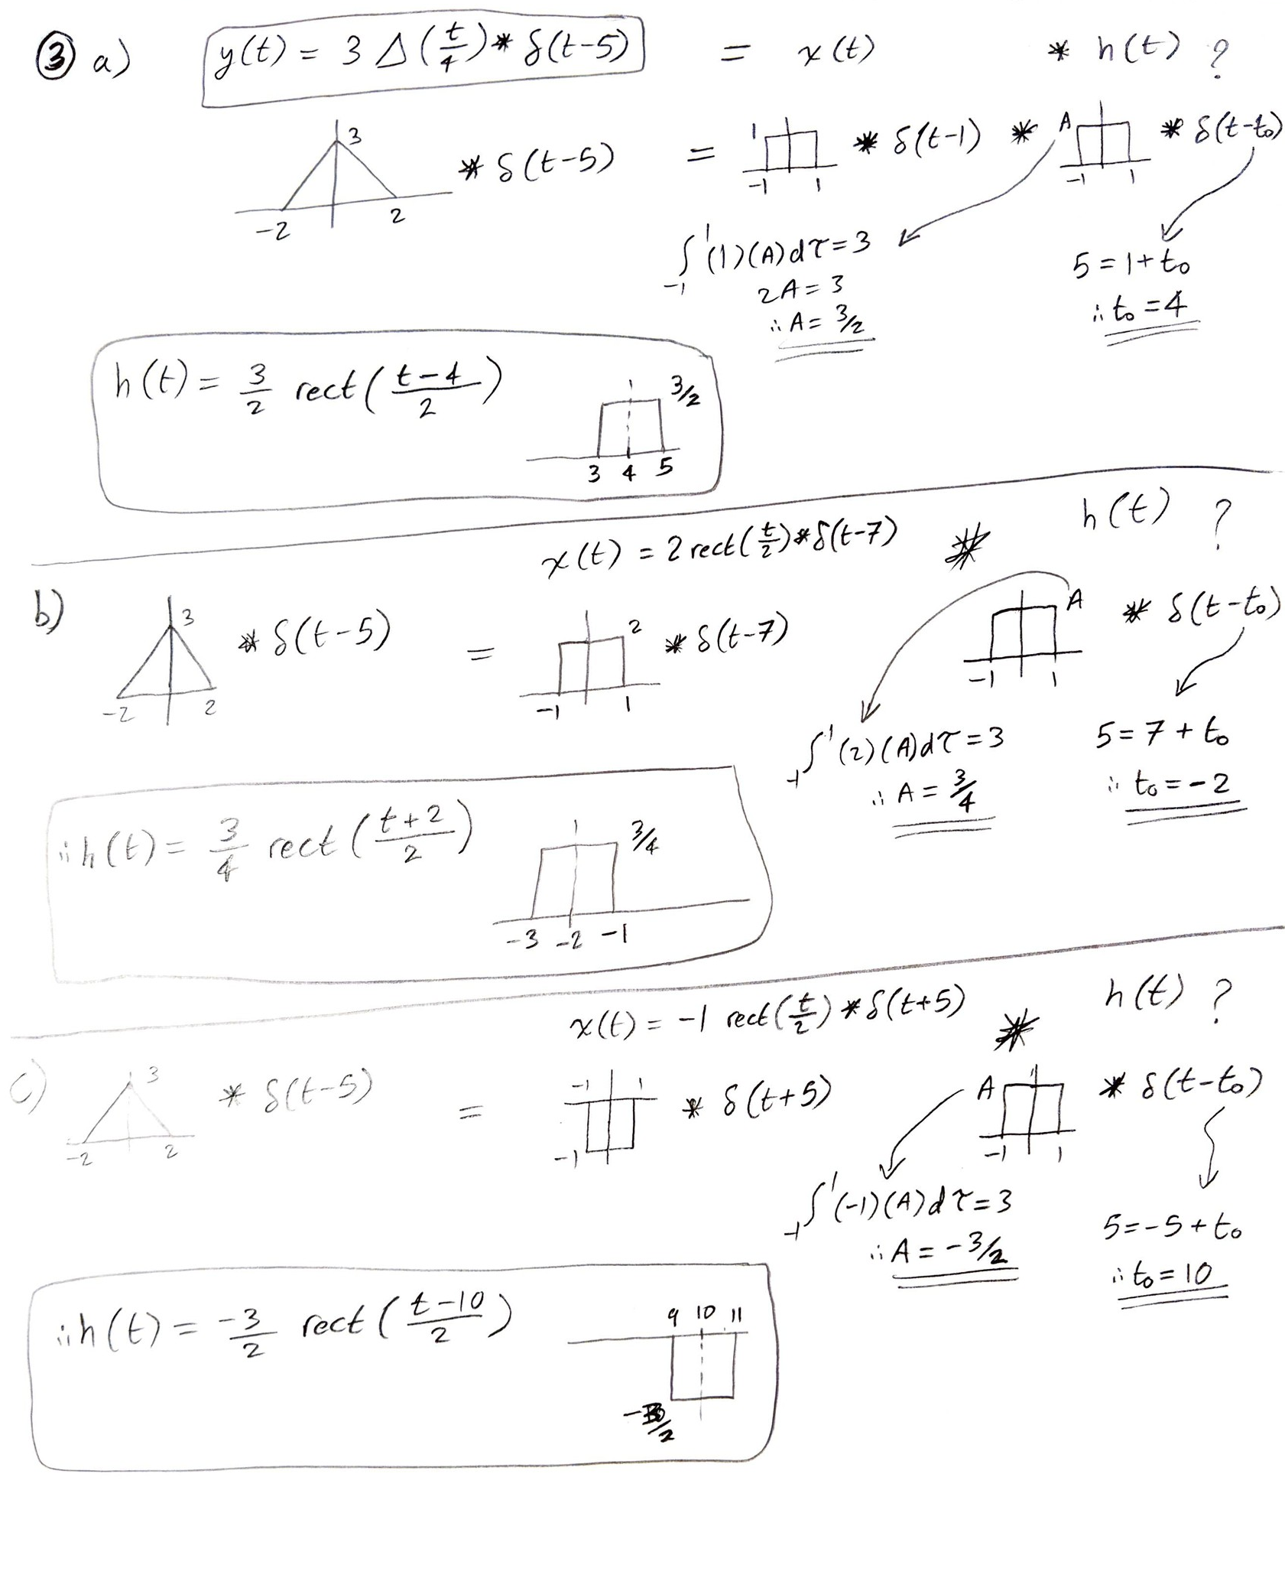

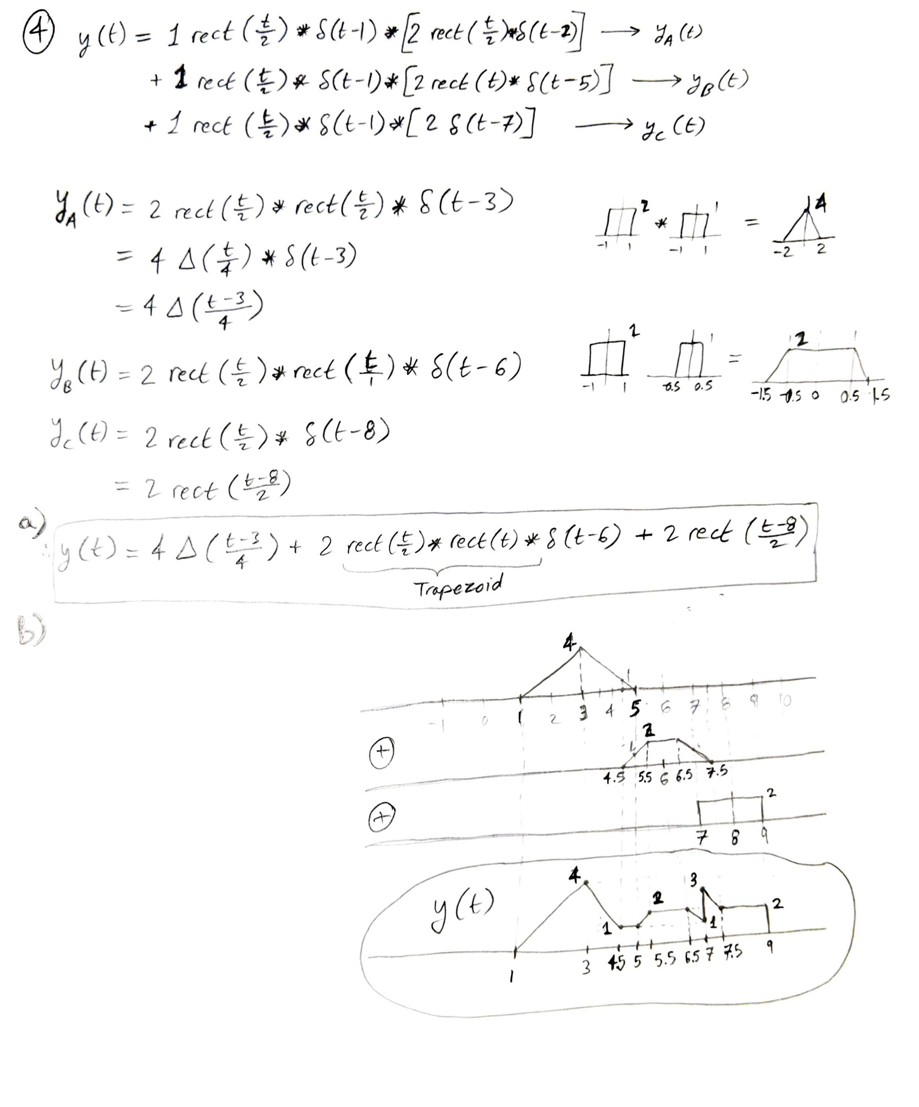

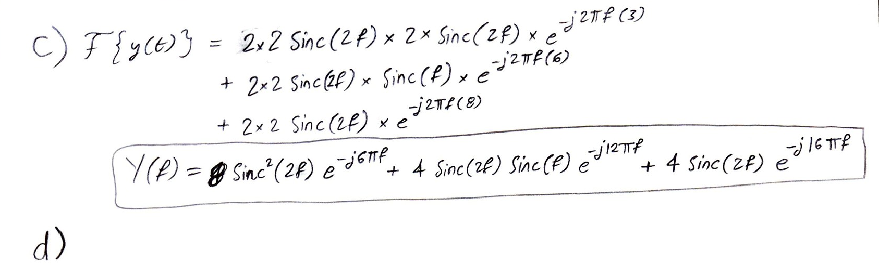

Matlab Code for Q4

syms f t

ex = exp(-j*2*pi*f*t);

x = 1; X = int(x*ex,t,0,2);

h1 = 2; H1 = int(h1*ex,t,1,3);

h2 = 2; H2 = int(h2*ex,t,4.5,5.5);

ya = 2; Ya = int(ya*ex,t,7,9);

Y = (X*H1)+(X*H2)+Ya;

Y = simplify(Y)

subplot(2,1,1); fplot(abs(Y)); title('Magnitue(Y)');

subplot(2,1,2); fplot(angle(Y)); title('Phase(Y)');

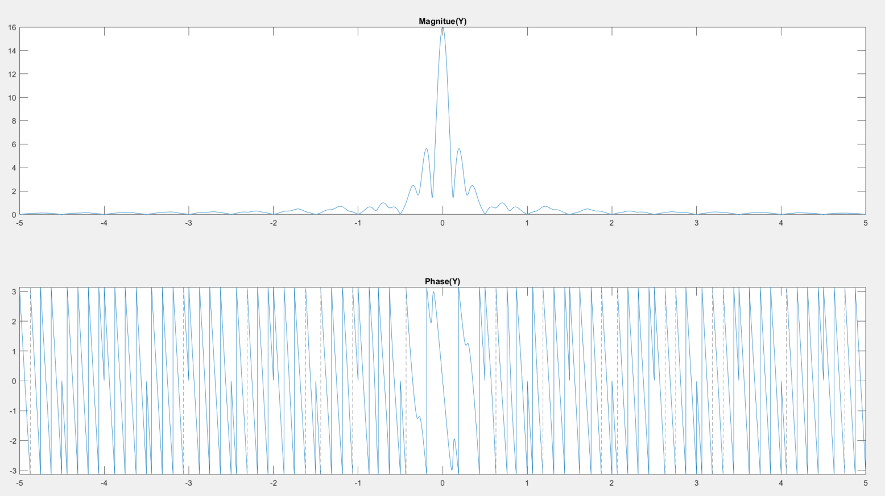

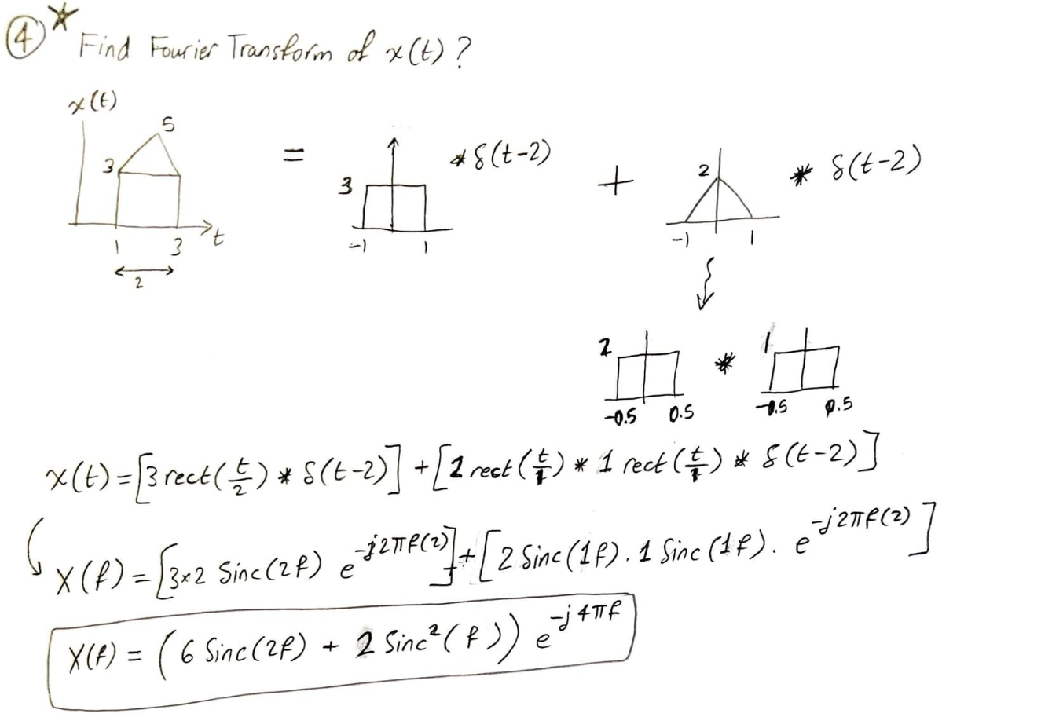

Matlab Code for Q4 (extra problem)

syms f t

ex = exp(-j*2*pi*f*t);

x1 = 3;

X1 = int(x1*ex,t,1,3);

x2 = 2*triangularPulse(1,3,t);

X2 = int(x2*ex,t,1,3);

Y = X1 + X2;

Y = simplify(Y)

subplot(2,1,1); fplot(abs(Y)); title('Magnitue(Y)'); axis([-5 5 -0.05 15])

subplot(2,1,2); fplot(angle(Y)); title('Phase(Y)'); axis([-5 5 -3.5 3.5])

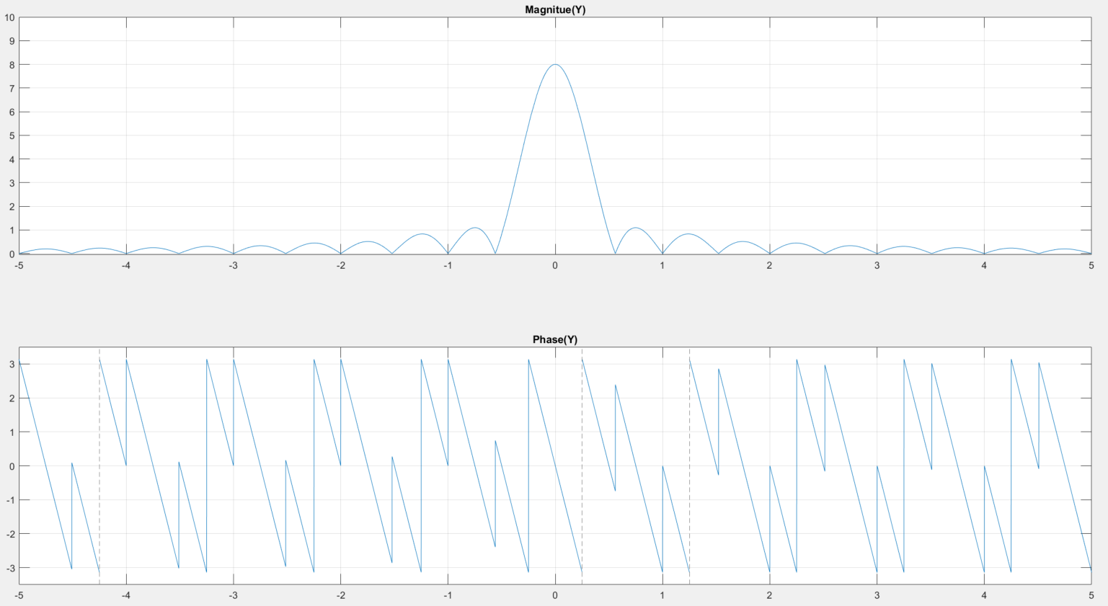

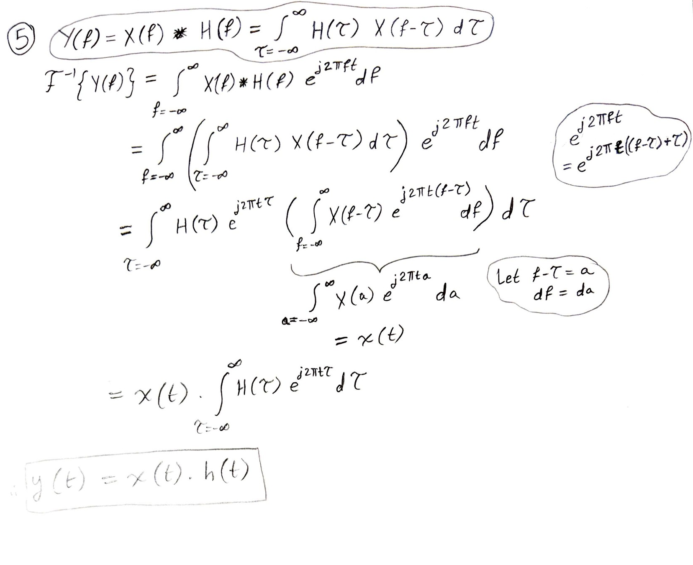

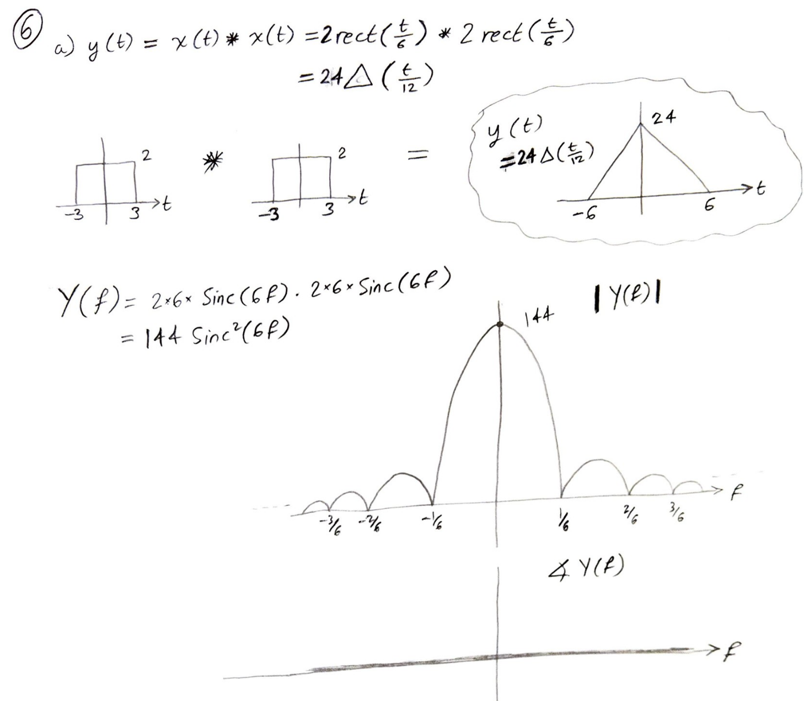

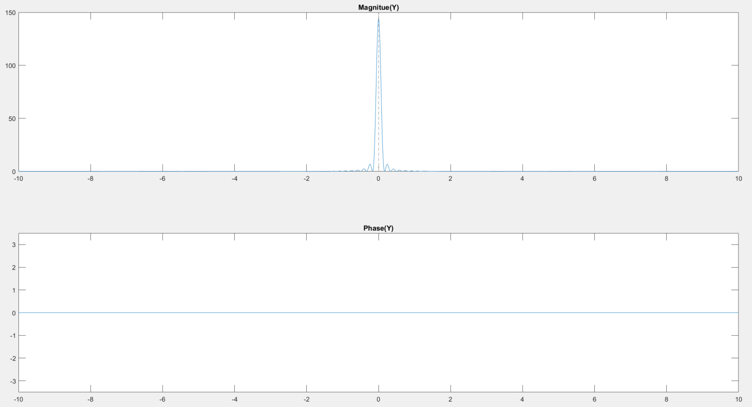

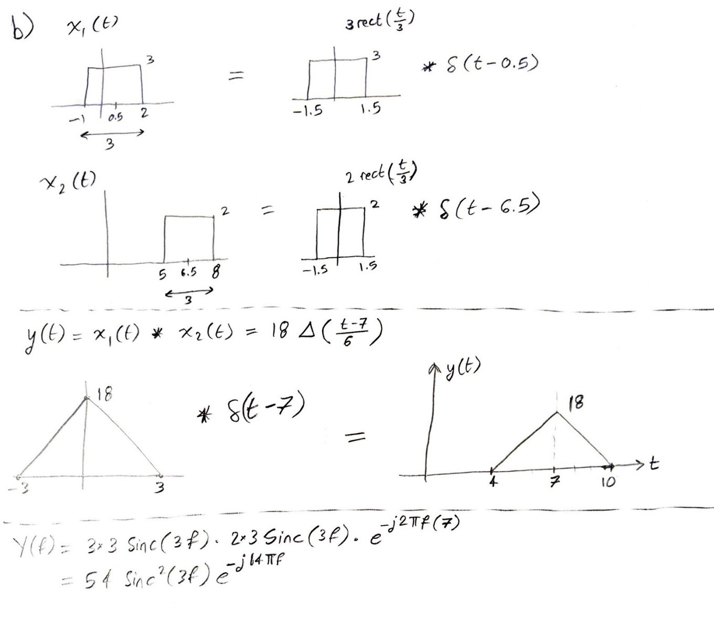

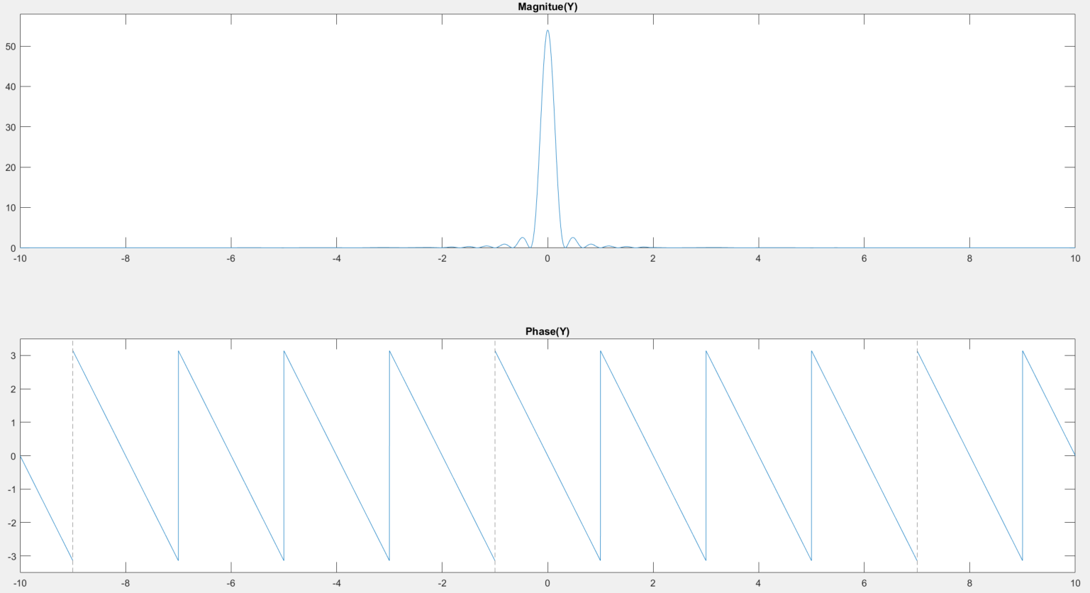

Matlab Code for Q6

* Part a):

syms f t

ex = exp(-j*2*pi*f*t);

x1 = 2;

X1 = int(x1*ex,t,-3,3);

x2 = 2;

X2 = int(x2*ex,t,-3,3);

Y = X1*X2;

Y = simplify(Y)

subplot(2,1,1); fplot(abs(Y)); title('Magnitue(Y)'); axis([-10 10 -0.05 150])

subplot(2,1,2); fplot(angle(Y)); title('Phase(Y)'); axis([-10 10 -3.5 3.5])

* Part b):

syms f t

ex = exp(-j*2*pi*f*t);

x1 = 3;

X1 = int(x1*ex,t,-1,2);

x2 = 2;

X2 = int(x2*ex,t,-1.5,1.5);

Y = X1*X2;

Y = simplify(Y)

subplot(2,1,1); fplot(abs(Y)); title('Magnitue(Y)'); axis([-10 10 -0.05 58])

subplot(2,1,2); fplot(angle(Y)); title('Phase(Y)'); axis([-10 10 -3.5 3.5])

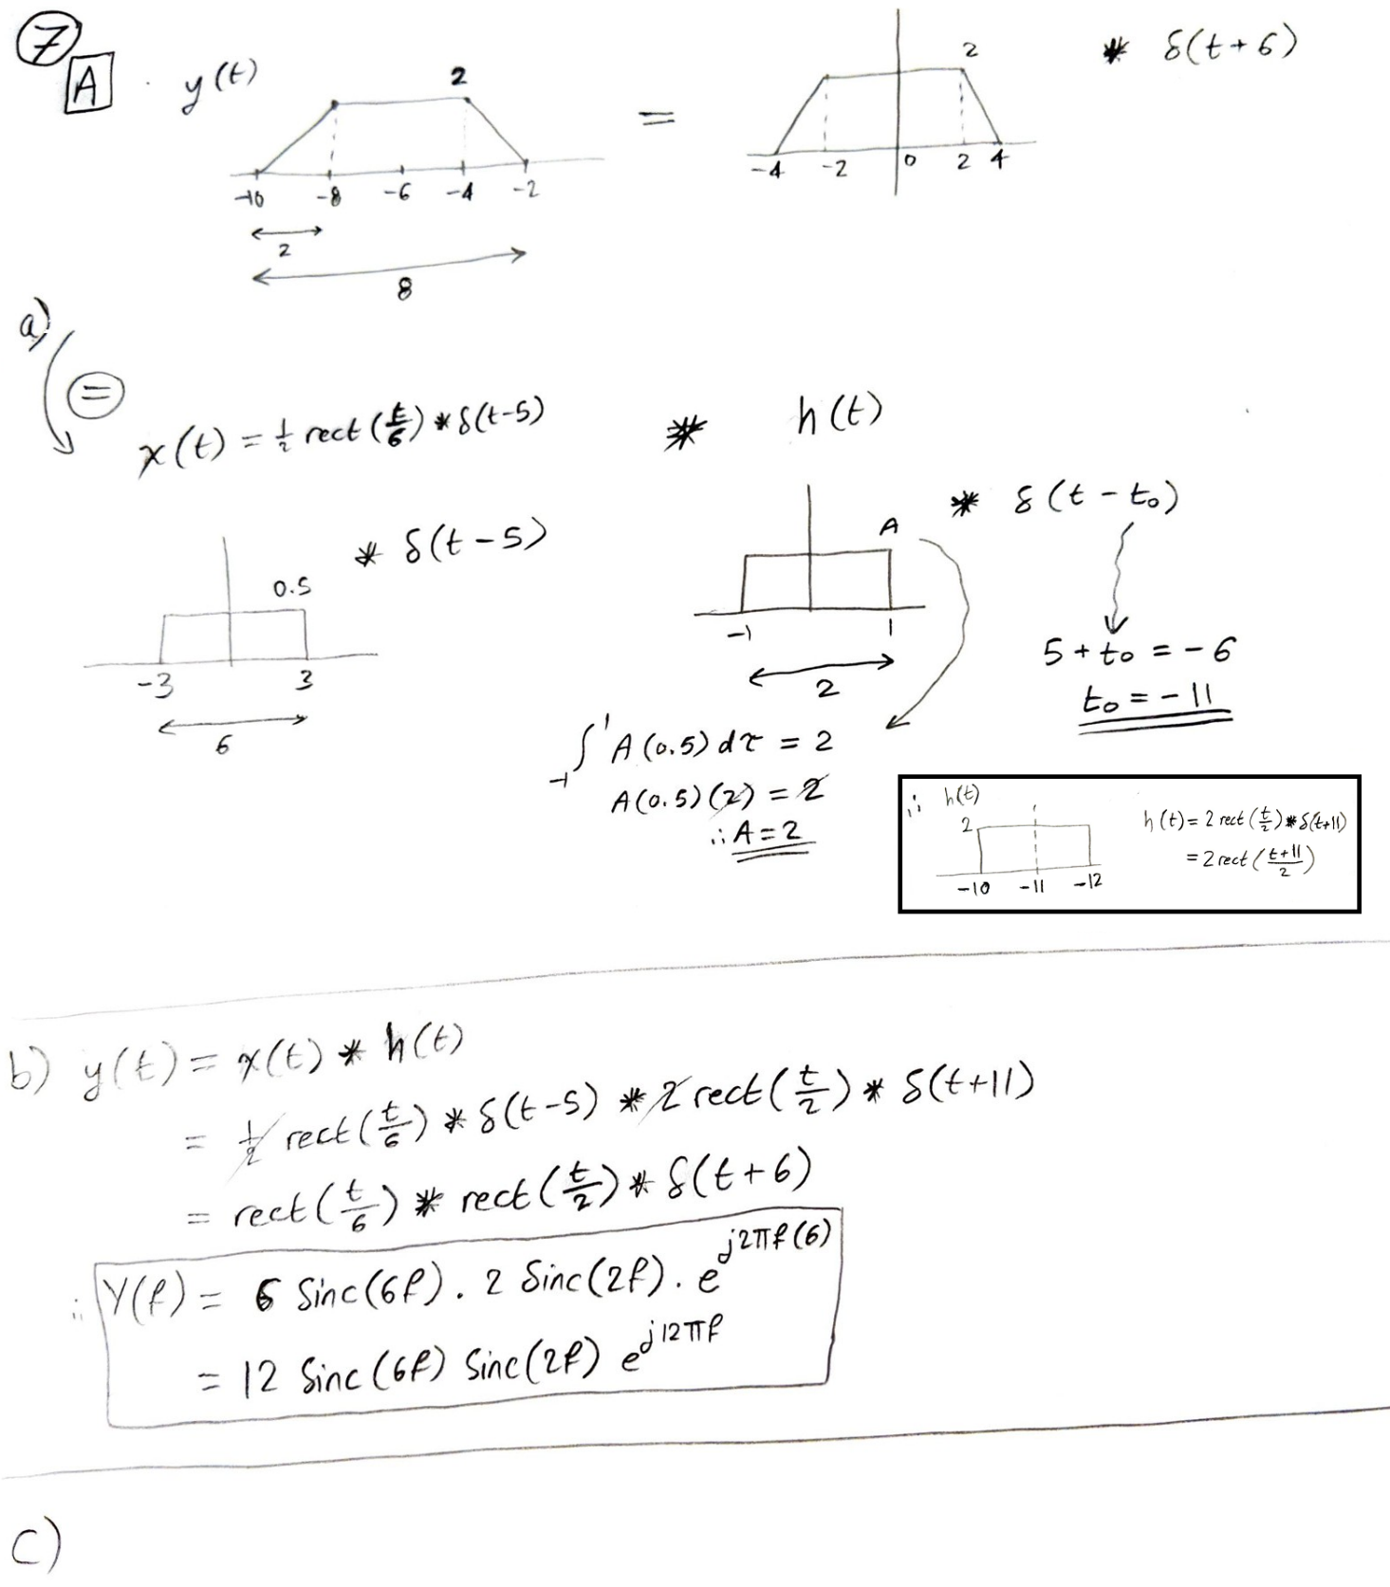

Matlab Code for Q7 (c):

syms f t

ex = exp(-j*2*pi*f*t);

X = int(0.5*ex,t,2,8);

H = int(2*ex,t,-10,-12);

Y = X*H;

Y = simplify(Y)

subplot(2,1,1); fplot(abs(Y)); title('Magnitude(Y)'); axis([-10 10 -0.05 14])

subplot(2,1,2); fplot(angle(Y)); title('Phase(Y)'); axis([-10 10 -3.5 3.5])

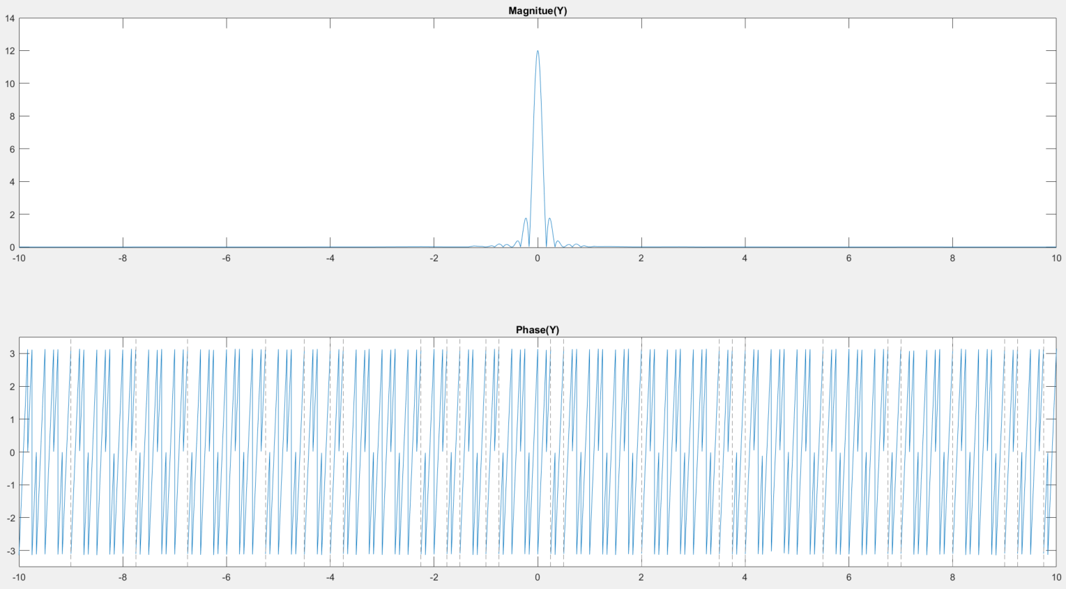

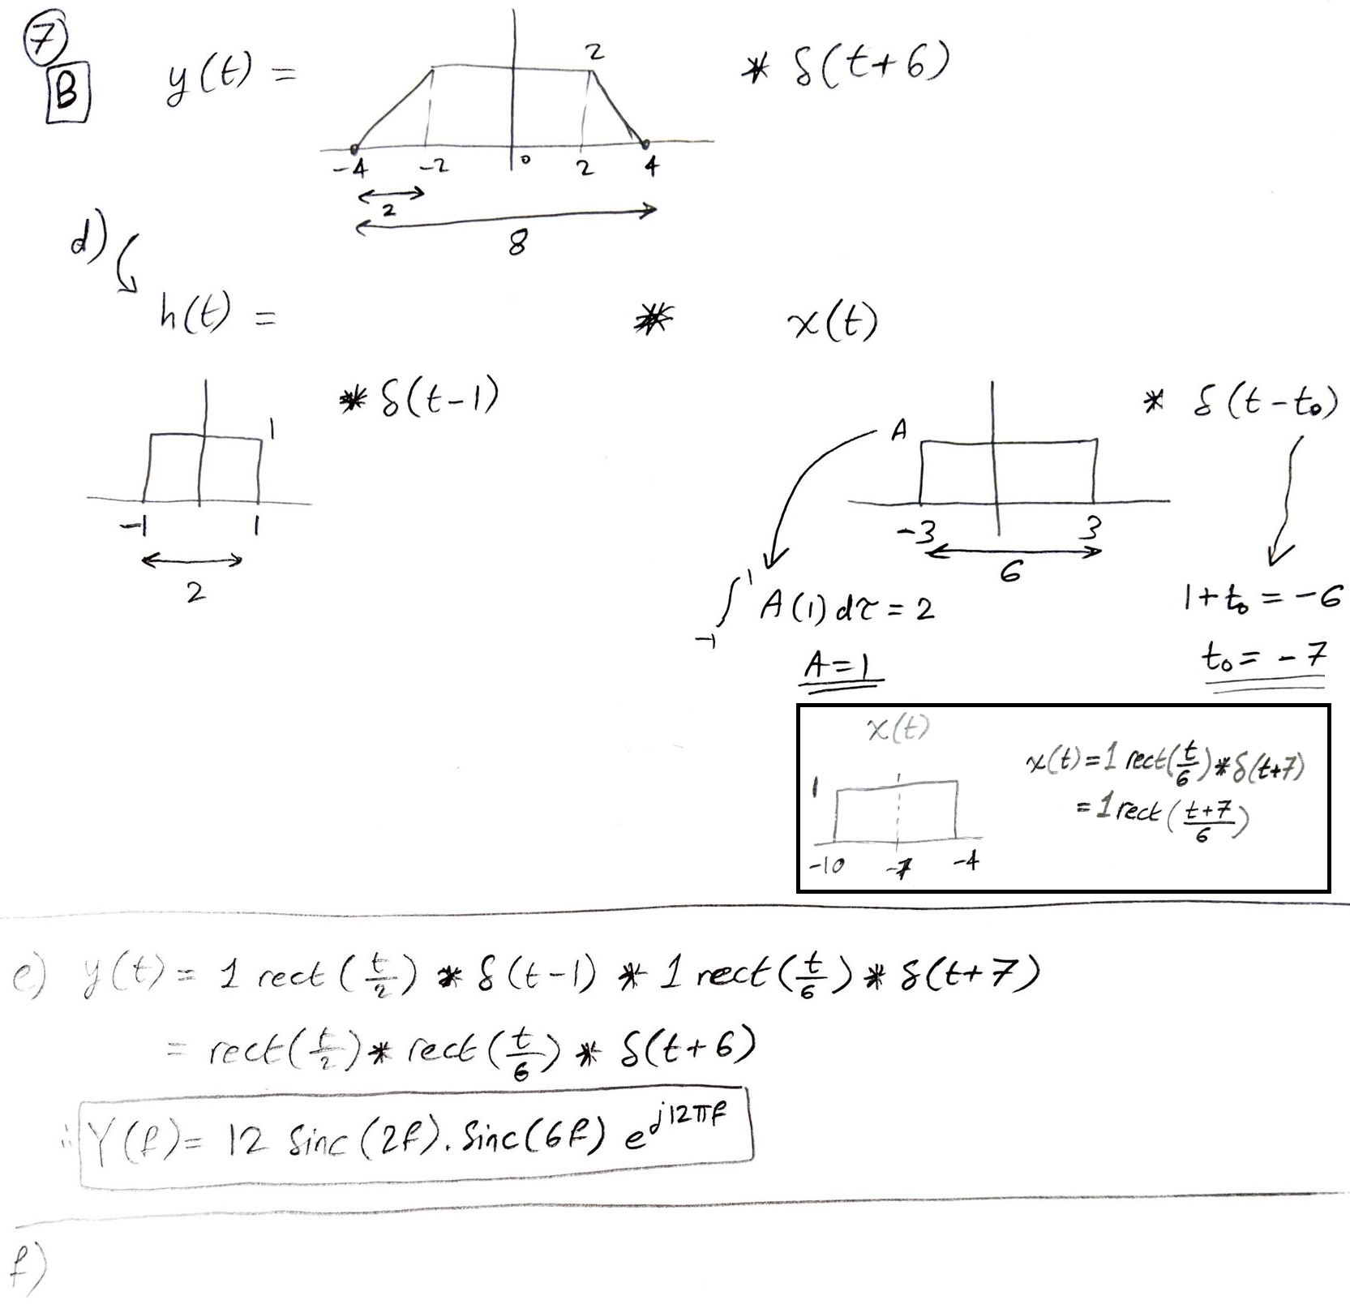

Matlab Code for Q7 (f):

syms f t

ex = exp(-j*2*pi*f*t);

X = int(0.5*ex,t,2,8);

H = int(2*ex,t,-10,-12);

Y = X*H;

Y = simplify(Y)

subplot(2,1,1); fplot(abs(Y)); title('Magnitue(Y)'); axis([-10 10 -0.05 14])

subplot(2,1,2); fplot(angle(Y)); title('Phase(Y)'); axis([-10 10 -3.5 3.5])

